'Jesus said: I am the light of the world.
Whoever follows me will have the light of life! John 8:12
Our Mission: 'Be the light'

Friday 1st May 2026

Dear parents/carers,

News from this week…

First Holy Communion preparation Mass
It was lovely to see so many of our Y4 children at Mass on Sunday. On Good Shepherd’s Sunday, Father Colm, invited us to be part of Jesus’ flock. We also asked parishioners to sponsor us during this special time and say special prayers for us.
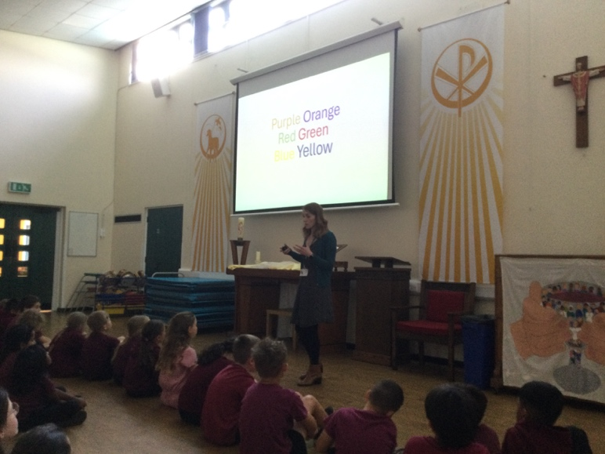
KS2 Career talk on Psychology
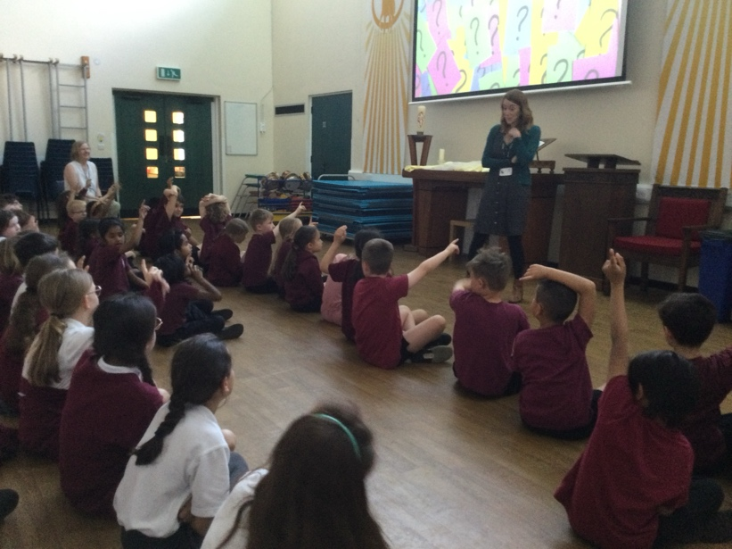

A very insightful career talk led by Mrs Hanley this afternoon on the role of a psychologist, then focussing specifically on the role of a developmental psychologist looking at how people grow and change across their lifestyle from infancy to old age. A huge thank you to Mrs Hanley for giving up her time to come in and talk to us.

Early Years Stay and Play sessions
We have already had two of our stay and play sessions this week and they have been so much fun. We have loved sharing our learning with parents and carers and giving them an insight into the work we do each day. We hope you have enjoyed them too. Dates continue next week.

Year 5 ‘Walking on Holy Ground’ retreat to Holy Island
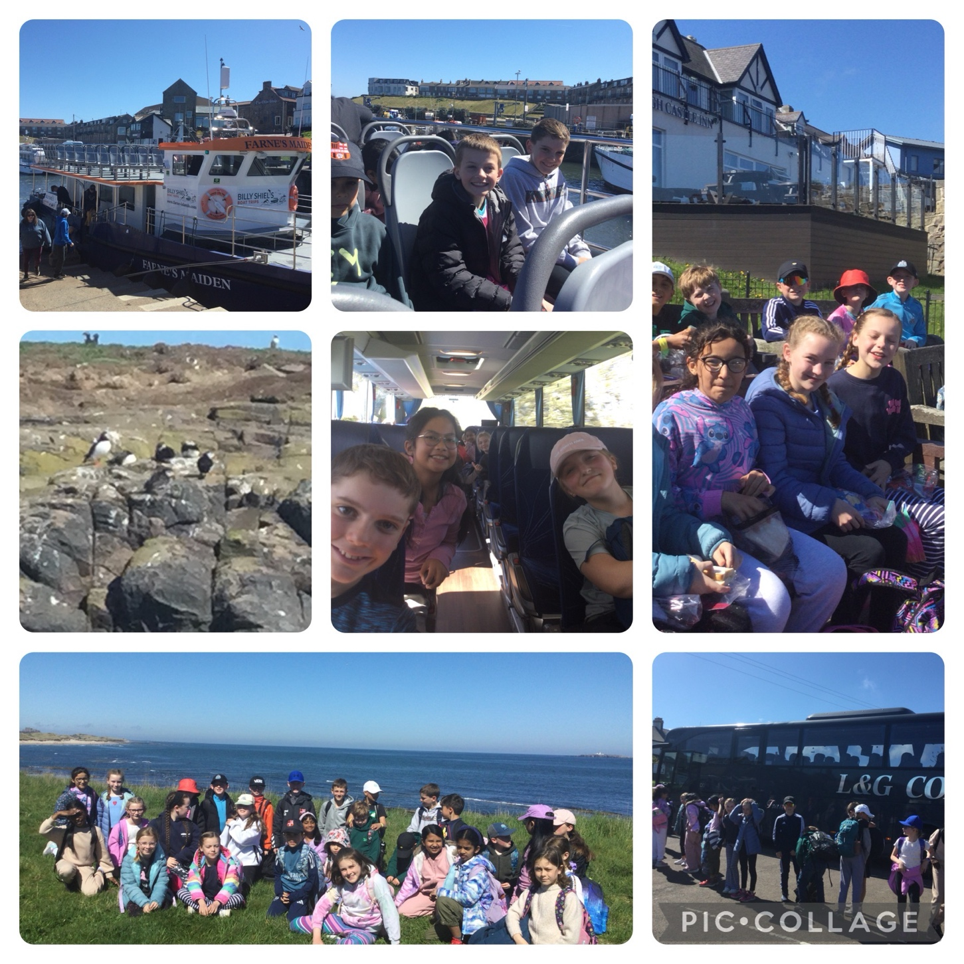
We had a wonderful few days away, blessed with beautiful weather. Our adventure began in Seahouses with a boat trip around the Farne Islands, followed by a lovely fish and chip meal together. We then walked across the causeway into Holy Island before settling into the SVP camp, where the staff took great care of us and cooked delicious meals. Over the next two days we visited Lindisfarne Priory and Castle, did some souvenir shopping, and prayed together as we remembered St Aidan, St Cuthbert, and others who had stood on the same holy ground we walked on. We also watched a movie and enjoyed hot chocolate. We ended our trip with a guided tour around Bamburgh Castle. The children were an absolute credit to the school throughout the whole trip.

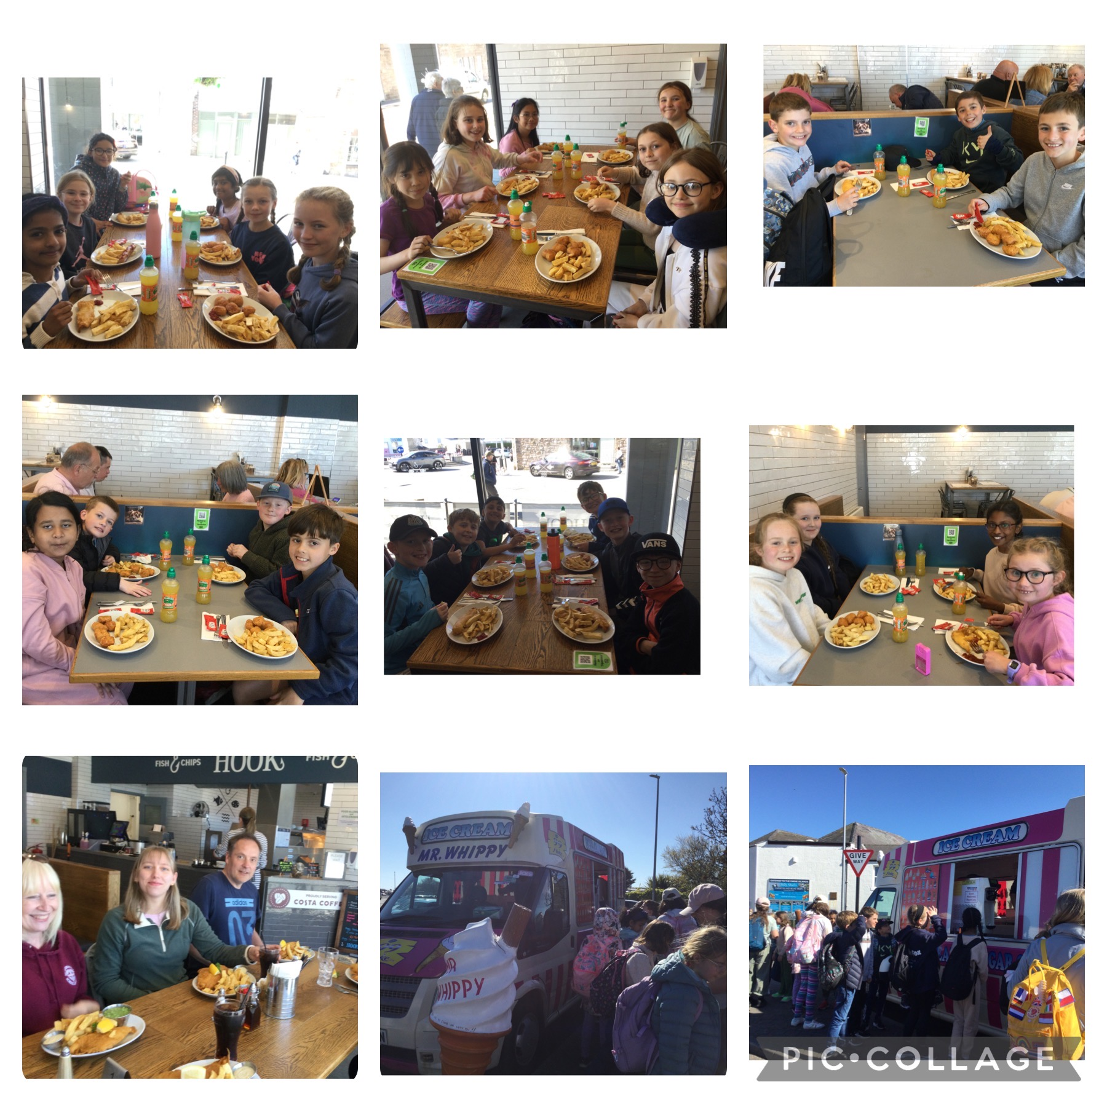

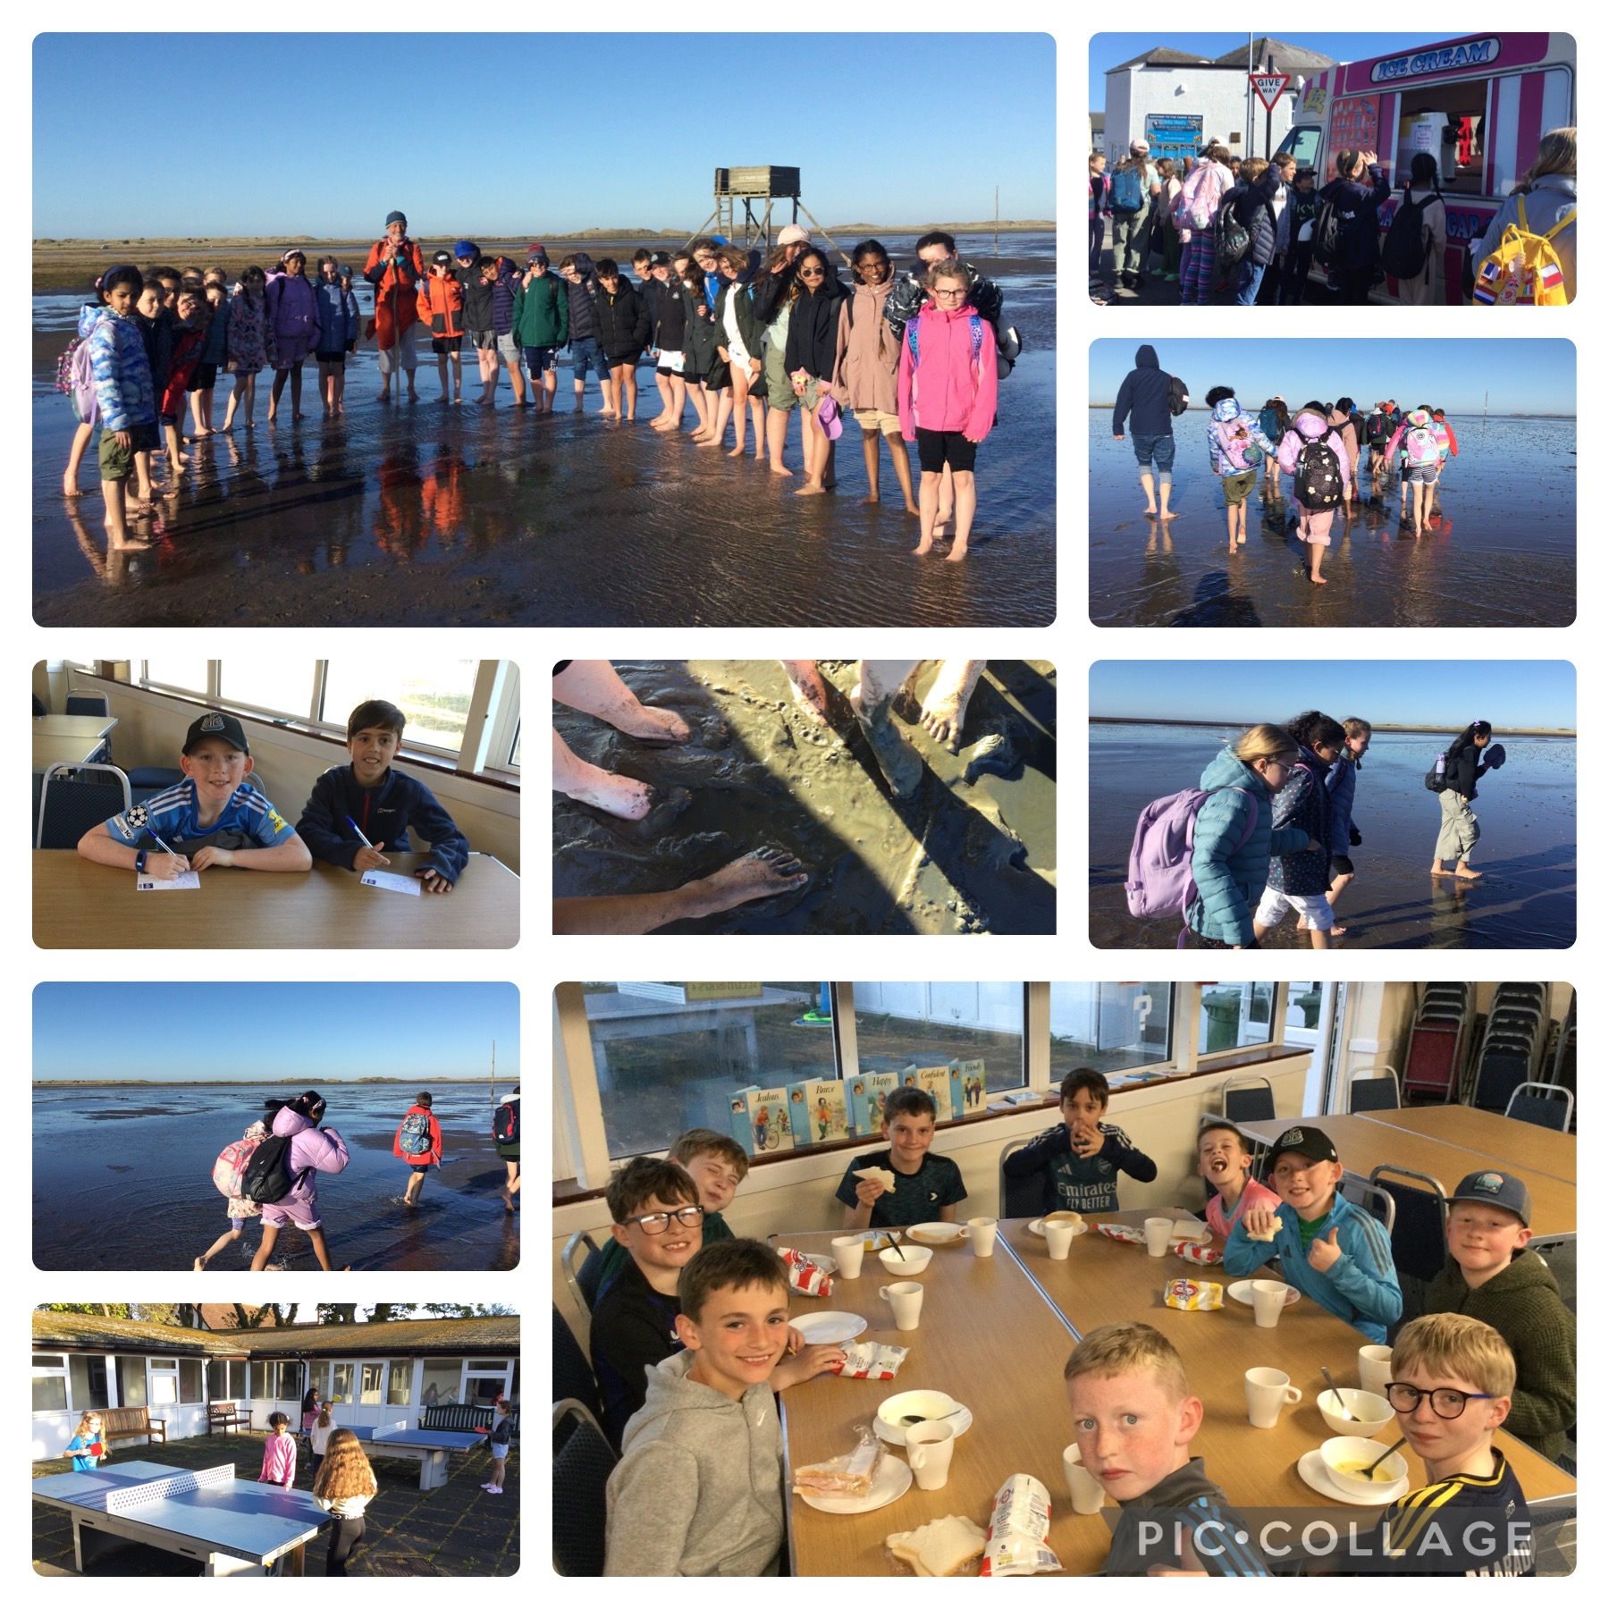

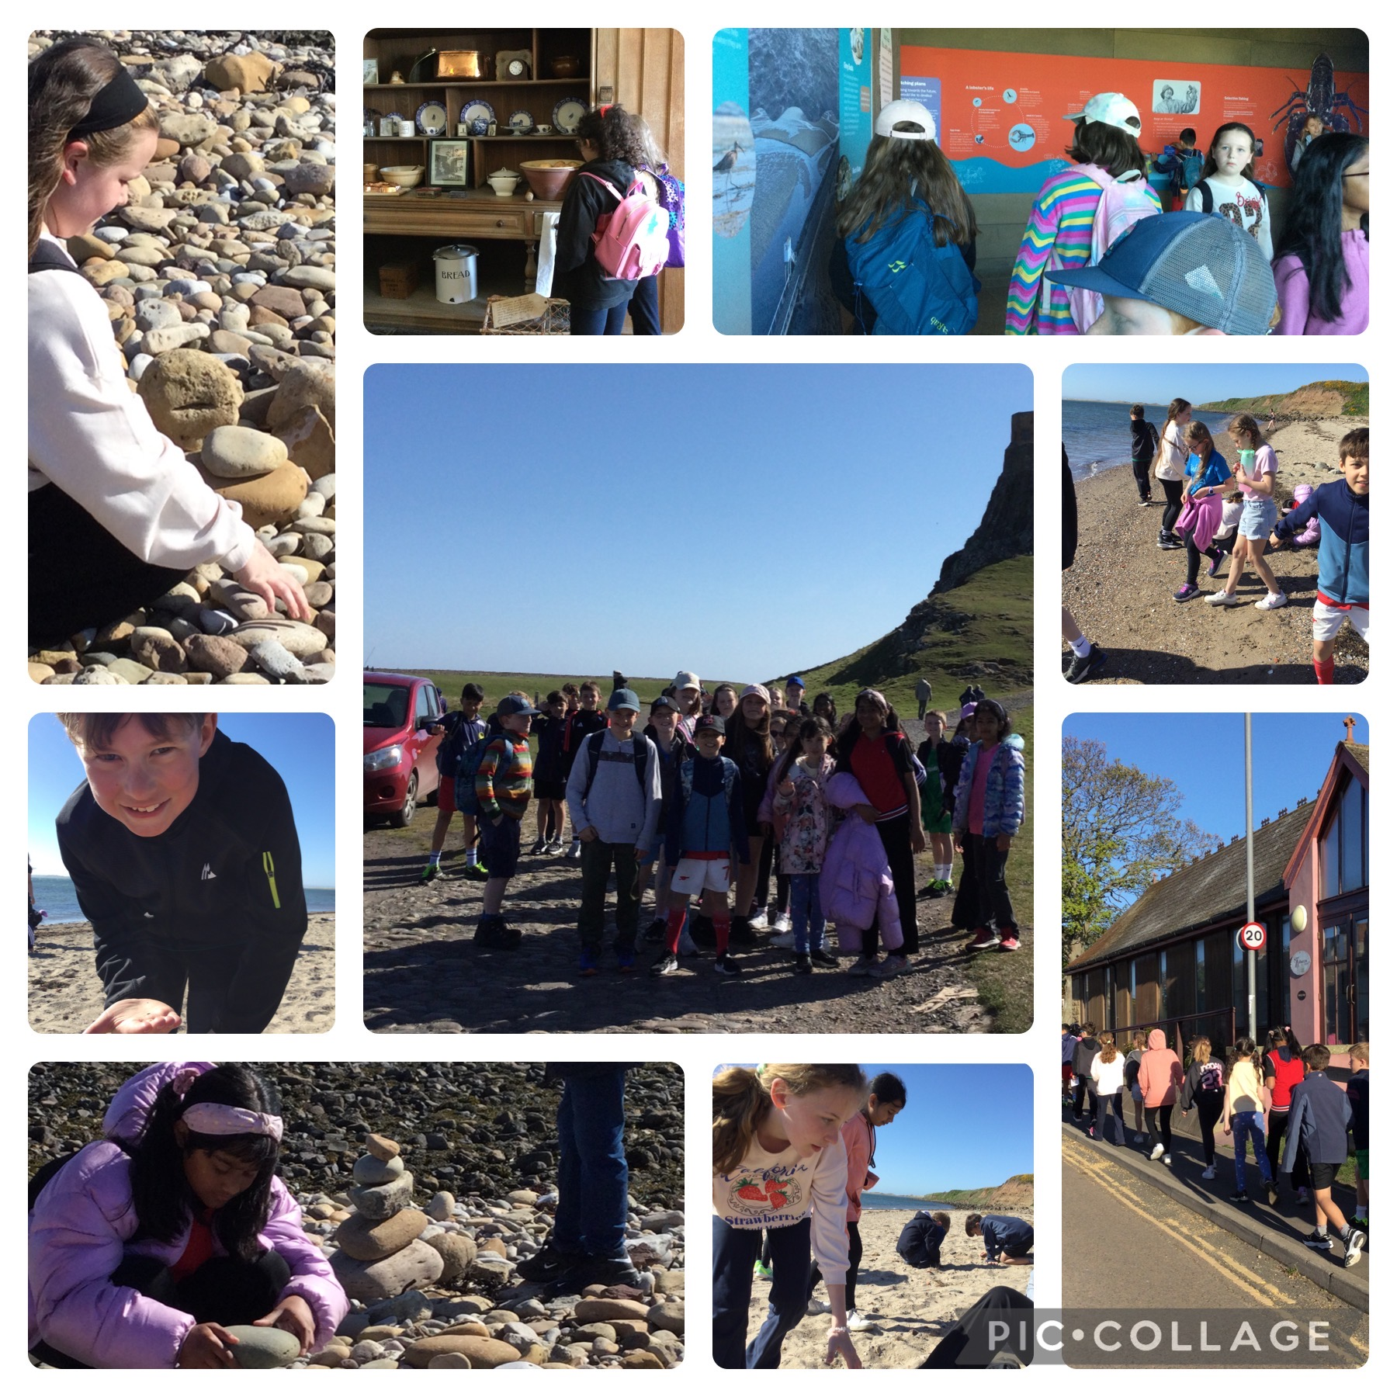

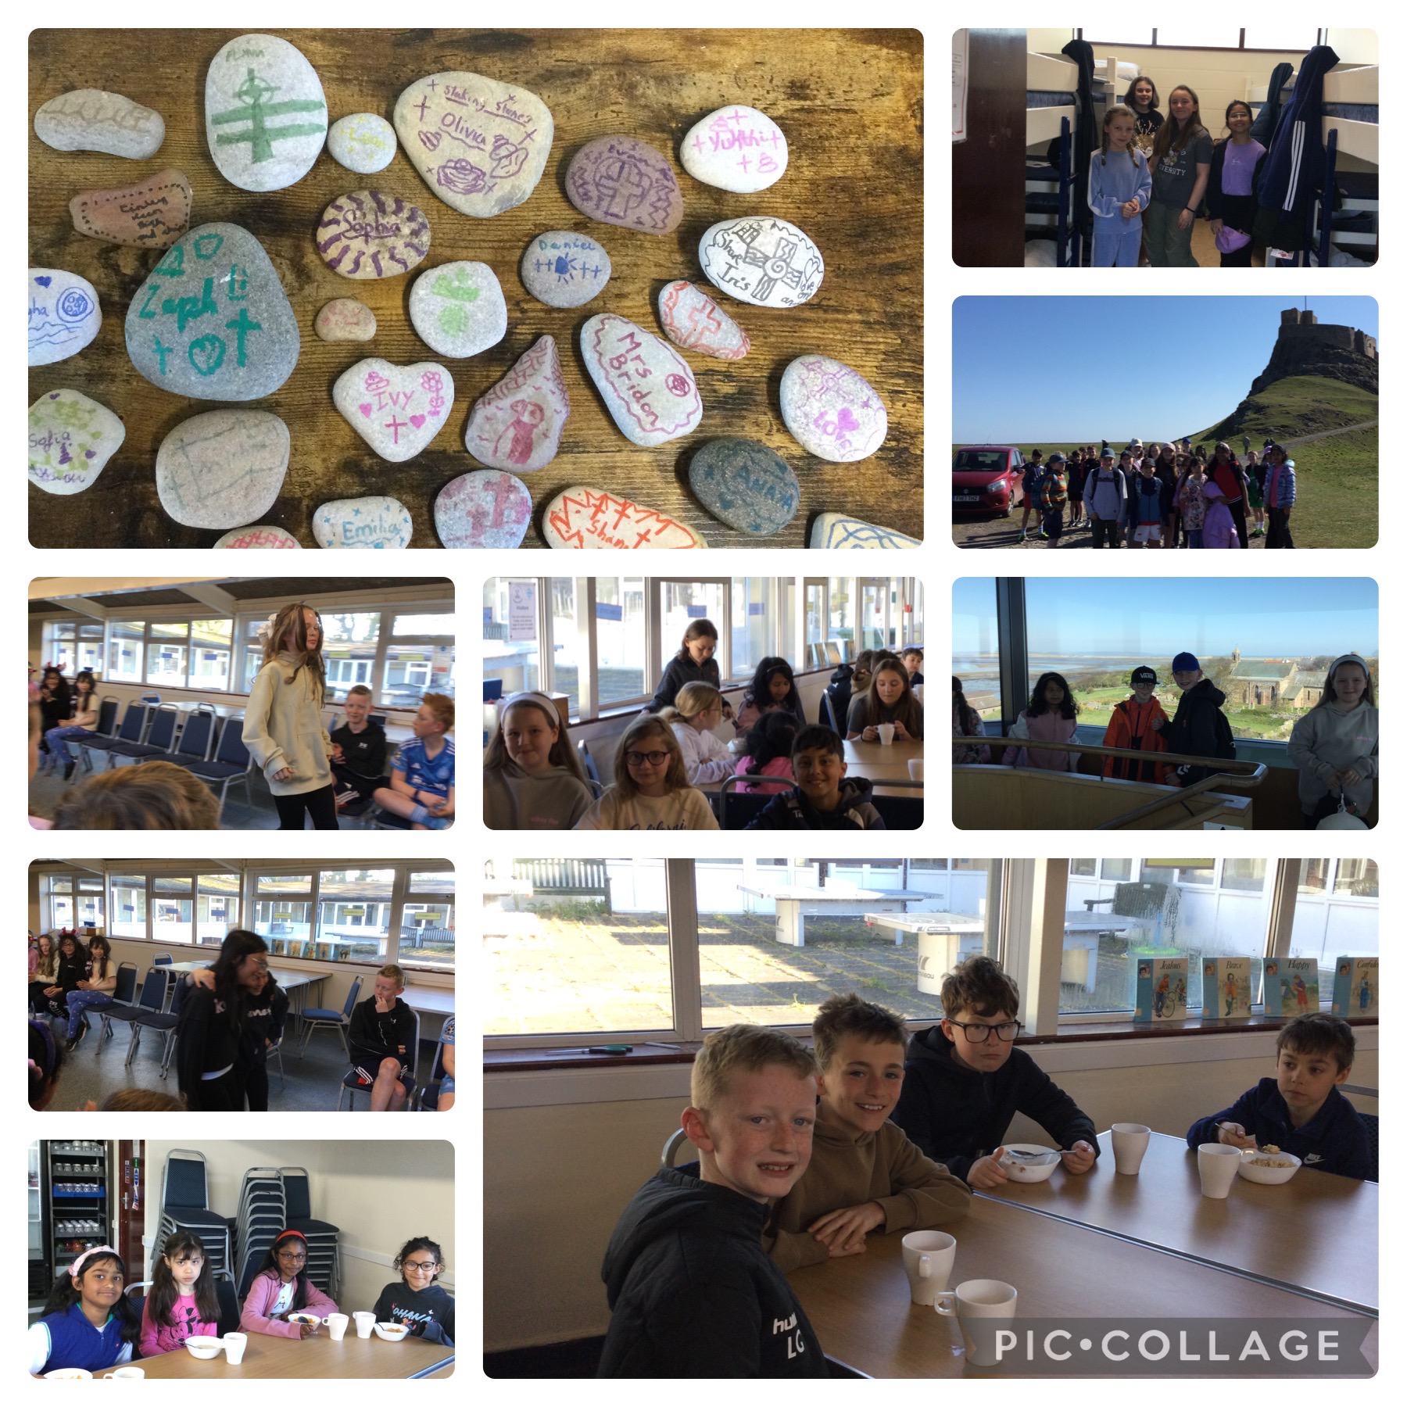

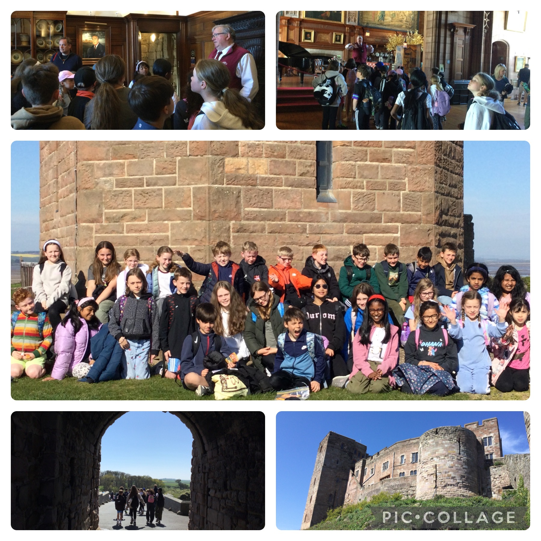

Friends of St. Godric’s News
There’s still time to get your tickets for the ceilidh on Friday 8th May - tickets will be on sale until the end of Wednesday 6th May. It’s a family friendly event and is always a really joyful evening so we hope you can join us!!

Donations for the raffle would be very welcome and there will be a cake table on the night too so baked goodies also very much appreciated! 💃 🕺🏾 🧁

https://www.tickettailor.com/events/friendsofstgodrics/2097454

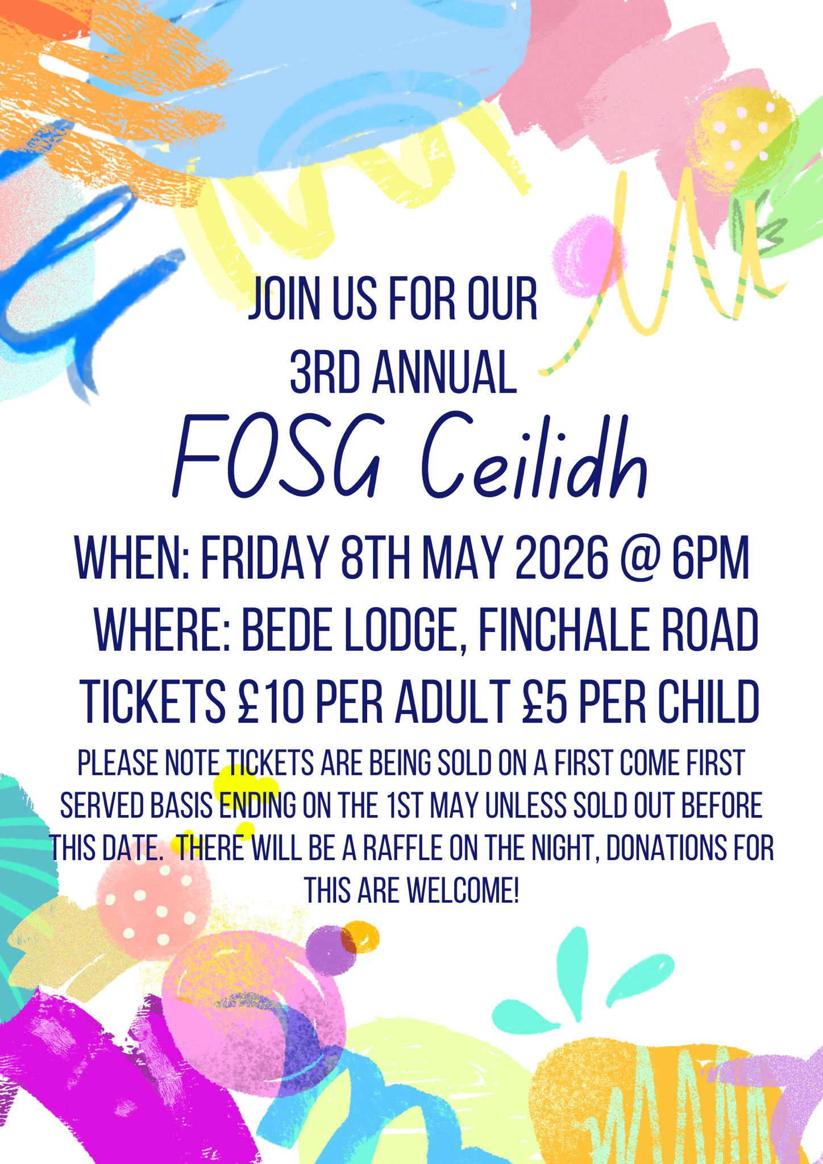

Suncream reminder
As we enter the warmer months, please ensure to apply suncream on your child before they come to school on sunny days. There are lots of creams that are long lasting. If children bring cream into school, they must be able to self-administer and only use their own.

Parish News
Rosary
During the month of May, the Parish of the Durham Martyrs will come together each Friday to pray the Rosary. Prayers will be for the intentions of all the members of the parish, with the schools included as a valued part of the parish.

The children and staff have been asked to write a small prayer or intention they would like to be included when the rosary is being prayed.

All intentions will be placed in a basket in front of the statue of Our Lady when we pray the Rosary on Friday 22nd May at St Joseph’s Church. Please note: these intentions will not be read aloud — they will remain private in the basket throughout the prayer. It would be wonderful if you could join us, but if you are unable to be there, please know that we will be very happy to pray for your intentions.

Youth group breakfast fundraiser on 17th May


Attendance this week
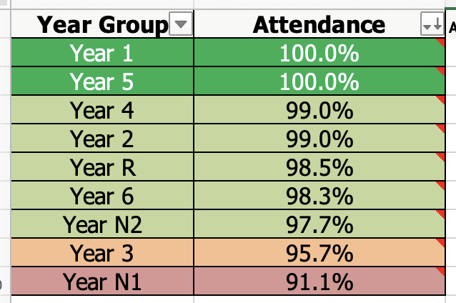
Our school target is 97.7%

Well done to Year 1 and Year 5 this week – fantastic attendance!
100%!

Coming up …

Monday 4th May Bank Holiday
Just a reminder that school is closed to all pupils and staff on Monday as it is a bank holiday.

Tues 5th May 2.15pm
Early Years Stay and play (invites have already been sent).

Wed 6th May AM
Early Years Sports Festival on school field with other local schools invited.

Wed 6th May 9am
Y4 to the Eucharistic Service

Thur 7th May PM
Community police to talk to Y3 and Y4 about Internet safety.

Fri 8th May 2.15pm
Early Years Stay and play (invites have already been sent).

Have a lovely weekend.

Kind regards


Mrs Bridon

